Unit 3: Polynomial Functions
3.4 Equations & Graphs of Polynomial Functions
Investigate
- Graph the function $f\left(x\right)=x^{4}+x^{3}-10x^{2}-4x+24$ using graphing technology.

- Determine the $x$-intercepts.

- Factor $f\left(x\right),$ then use the factors to find the zeros.

- Solve the polynomial equation $x^{4}+x^{3}-10x^{2}-4x+24=0$.

- What is the relationship between the zeros of a function, the x-intercepts of the corresponding graph and the roots of the polynomial equation?

- Refer to the graph in #1. The x-intercepts divide the x-axis into four intervals. Complete the chart below filling in the four intervals and whether the function is positive (above the x axis) or negative (below the x axis).
Interval | $$x<-3$$
Sign of $f(x)$ | positive

Just like with quadratic functions, the zeros of any polynomial function $y=f(x)$ correspond to the x-intercepts. (Remember, no real roots, 2 equal real roots, 2 unequal real roots?)
Multiplicity (of a zero):

Zero of Multiplicity 1 Zero of Multiplicity 2 Zero of Multiplicity 3
$y=(x-1)(x+1)(x+3)$ $y={(x+1)}^{2}(x-3)$ $y=x^{3}$
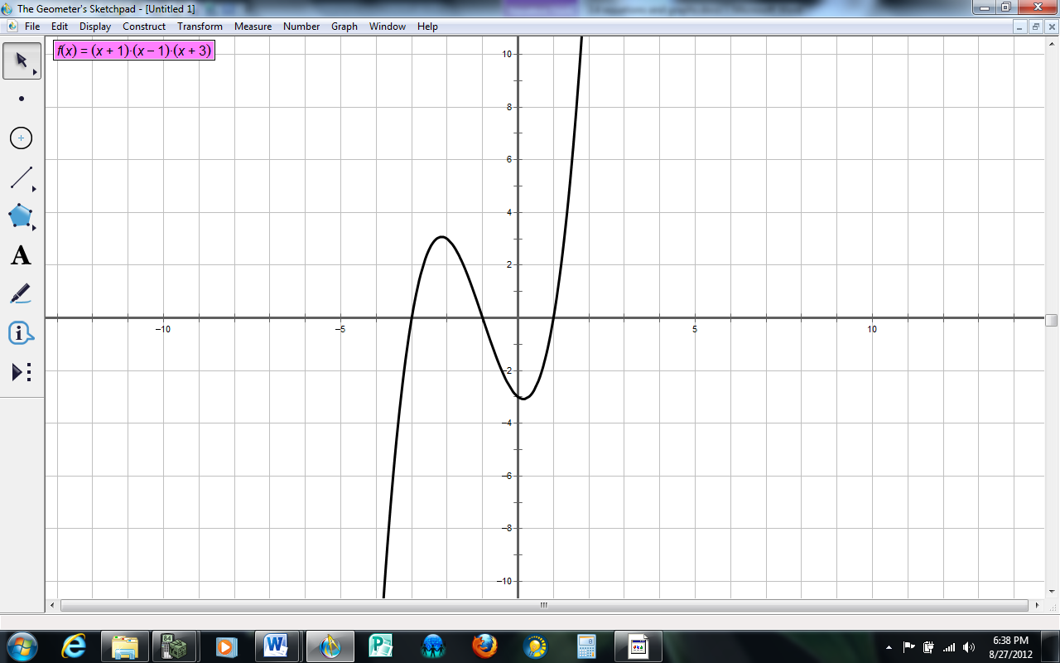
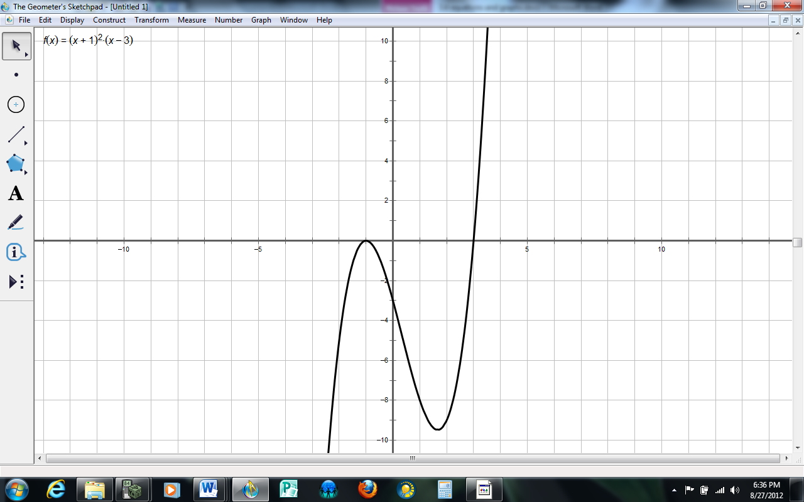
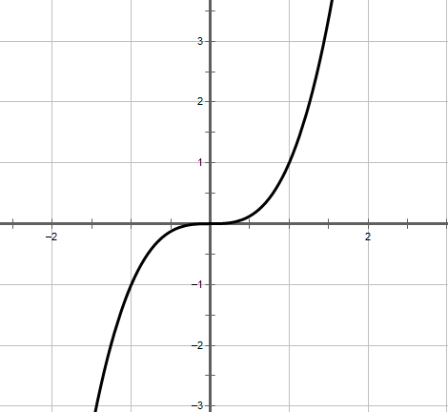

At a zero of odd multiplicity, the sign of the function __________________.
At a zero of even multiplicity, the sign of the function ________________________.
Ex. For each graph of a polynomial function, determine
- the least possible degree
- the sign of the leading coefficient
- the x-intercepts and the factors of the function with least possible degree
- the intervals where the function is positive and where it is negative
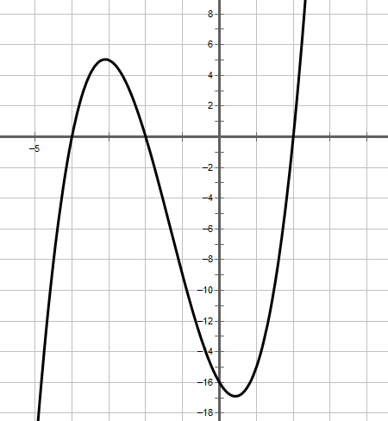
a)

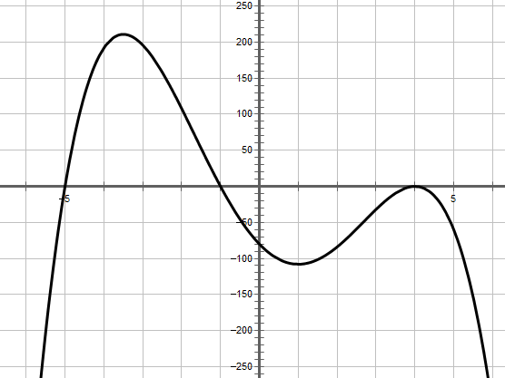
b)

Ex. Sketch the graph of each polynomial function.
- $y=(x-1)(x+2)(x+3)$ b) $y=-{\left(x+1\right)}^{3}(x-4)$
Degree
Leading Coefficient
End Behavior
Zeros/x-intercepts
y-intercept
Intervals Positive & Negative

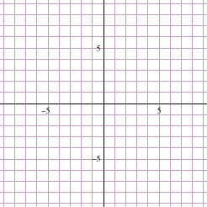

What if you had to sketch the polynomial function $y=-2x^{3}+6x-4$?

Ex. The graph of $y=x^{3}$ is transformed to obtain the graph of $y=-2{\left(4\left(x-1\right)\right)}^{3}+3$.
- Describe the transformations

- Complete the table to show what happens with each transformation.

$$y=x^{3}$$ | $y={(4x)}^{3}$ | $y=-2{(4x)}^{3}$ | $$y={-2(4(x-1)}^{3}+3$$
(-2, -8)
(-1, -1)
(0, 0)
(1, 1)
(2, 8)

- Sketch the graph of $y=-2{\left(4\left(x-1\right)\right)}^{3}+3$.

Ex. Bill is preparing to make an ice sculpture. He has a block of ice that is 3 ft wide, 4 ft high, and 5 ft long. Bill wants to reduce the size of the block of ice by removing the same amount from each of the three dimensions. He wants to reduce the volume of the ice block to 24 ft³. Write a polynomial function to model the situation and then find the new dimensions.

Practice: pg. 147/# 2 – 6, 9, 10, 12 – 14, 16

