Unit 2: Conics
2.3 Hyperbolas

Basic hyperbola:
$x^{2}-y^{2}=1$ $x^{2}-y^{2}=-1$ or $y^{2}-x^{2}=1$
Horizontal Transverse Axis Vertical Transverse Axis
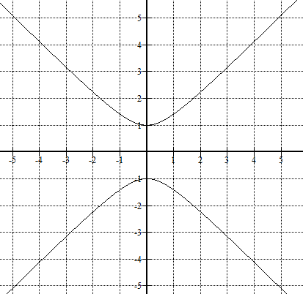
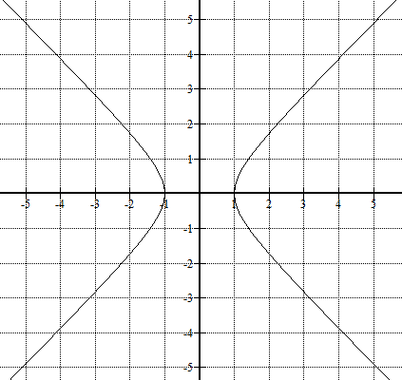

Asymptotes: $y=±x$
Transverse Axis: connects the vertices
Conjugate Axis: perpendicular to the transverse axis

Ex. Graph each conic on the grid provided:
$\frac{{(x-2)}^{2}}{16}-\frac{{(y+3)}^{2}}{4}=1$ $\frac{{(y-1)}^{2}}{9}-\frac{{(x+2)}^{2}}{16}=1$

$4x^{2}-25{(y+1)}^{2}=-100$

Ex. Write the equation of each conic shown:


