Unit 2: Conics
2.1 Conics Intro & Parabolas

Conic Sections – resulting curves when a double-napped right circular cone is intersected by a plane
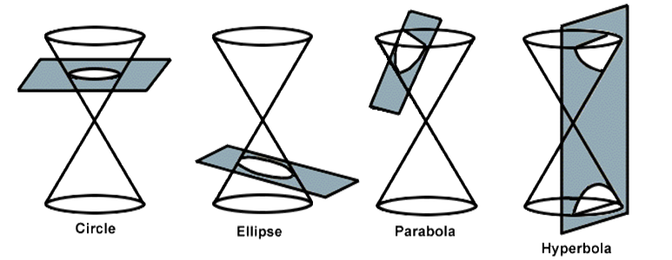
Circle – plane parallel to the base (perpendicular to the central axis)
Ellipse – plane at an angle but not through the base (an intersection that creates a closed curve)
Parabola - plane parallel to the surface of the cone
Hyperbola – plane parallel to the central axis (perpendicular to the base

From PreCalculus 11 we are familiar with quadratics whose resulting parabola graphs are vertically opening (up or down):
$$y={a\left(x-p\right)}^{2}+q$$
Vertex: $\left(p,q\right)$
Vertical axis of symmetry (a/s): $x=p$
Domain: $\left\{x | x∈R\right\}$
Range: $\left\{y | y≥q, y∈R\right\}$ if $a>o$ ie. opens up
$\left\{y | y≤q, y∈R\right\}$ if $a<o$ ie. opens down

In Conics we will also have quadratics whose resulting parabola graphs are horizontally opening (right or left):
$$x={a\left(y-q\right)}^{2}+p$$
Vertex: $\left(p,q\right)$
Horizontal axis of symmetry (a/s): $y=q$
Domain: $\left\{x | x≥p, x∈R\right\}$ if $a>o$ ie. opens right
$\left\{x | x≤p, x∈R\right\}$ if $a<o$ ie. opens left
Range: $\left\{y | y∈R\right\}$

Ex. Graph each conic on the grid provided:
$y=-\frac{1}{2}{\left(x+3\right)}^{2}+5$ $x=2{\left(y+3\right)}^{2}-6$
Ex. Write the equation of each conic shown:


