Unit 4: Radical Expressions & Equations
4.1 Rational Exponents & The Real Number System

Connecting Rational Exponents and Radicals

We can use our exponent laws to deal with rational exponents, but what do they mean?

$\left({25}^{\frac{1}{2}}\right)\left({25}^{\frac{1}{2}}\right)=$

What else when multiplied by itself gives a product of 25? ________

What is the relationship between ${25}^{\frac{1}{2}}$ and 5?

Label: $\sqrt[n]{x}$
Rational Exponent Law:

Ex. Express each power as an equivalent radical. Evaluate where possible.
- ${64}^{\frac{1}{2}}$ b) ${16}^{\frac{3}{4}}$ c) ${\left({8x}^{2}\right)}^{\frac{1}{3}}$

Ex. Express each radical as a power with a rational exponent.
- $\sqrt[4]{5^{3}}$ b) $\left(\sqrt[n]{{27}^{2}}\right)$ c) $\left(\sqrt{s^{3}}\right)$

Ex. Simplify and evaluate where possible.
- ${\left({27x}^{6}\right)}^{\frac{2}{3}}$ b)${\left[\left(x^{\frac{4}{3}}\right)\left(x^{\frac{1}{3}}\right)\right]}^{9}$ c) ${\left(\frac{x^{3}}{64}\right)}^{-\frac{2}{3}}$

Number Sets:
Place the letter corresponding with the correct description in the appropriate area on the diagram.
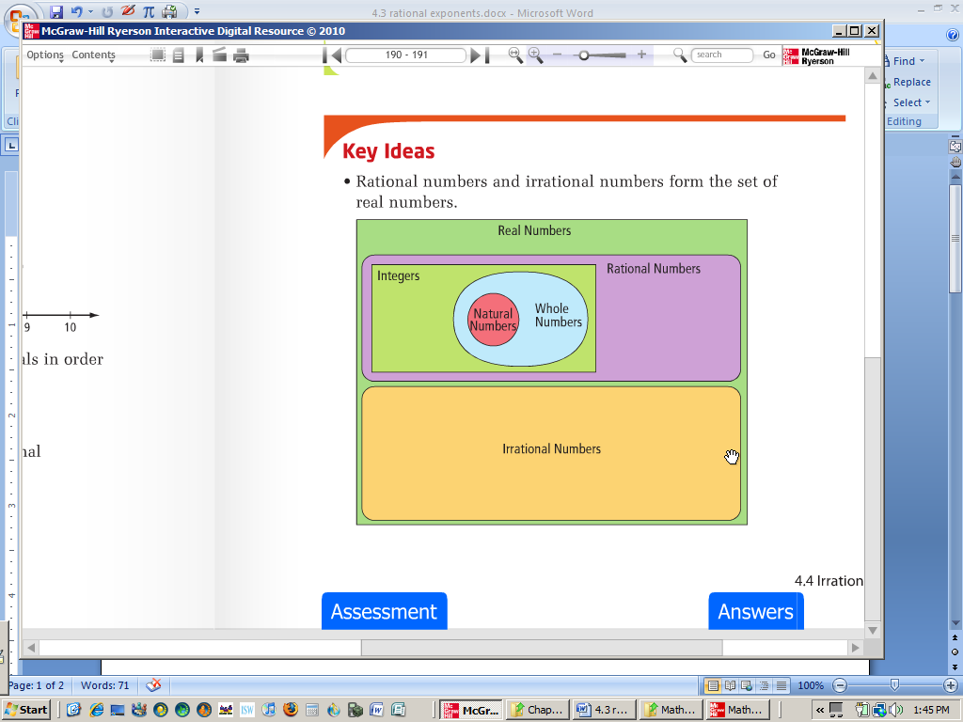
A.
Examples include $π$ & $\sqrt{2}$

B.
Examples include $0.3, \frac{4}{5}, \& \sqrt{25}$
C.
1, 2, 3,…
D.
…-3, -2, -1, 0, 1, 2, 3…
E.
0, 1, 2, 3,…
F.
All rational & irrational numbers

Practice: Worksheet (Connecting Rationals and Radicals)

