Unit 3: Quadratic Equations
3.1 Graphical Solutions of Quadratic Equations

Quadratic Equation:

Root(s) of an equation:

Zero(s) of a function:

ex. Determine the roots of each equation by graphing by hand:

$x^{2}-8x+16=0$ $-2x^{2}=8x$ $3x^{2}=-1$

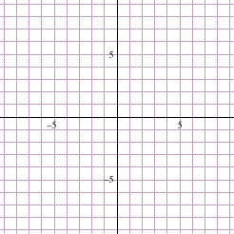

Check:

Possible number of solutions to a quadratic equation:

ex. The manager of Jasmine’s Fine Fashions is investigating the effect that raising or lowering dress prices has on the daily revenue from dress sales. The function $R\left(x\right)=100+15x-x^{2}$ gives the store’s revenue R, in dollars, from dress sales, where x is the price change, in dollars. What price changes will result in no revenue?

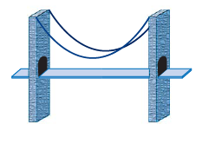
ex. The curve of a suspension bridge cable attached between the tops of two towers can be modeled by the function $h\left(d\right)=0.0025{\left(d-100\right)}^{2}-10$, where h is the vertical distance from the top of a tower to the cable and d is the horizontal distance from the left end of the bridge, both in meters. What is the horizontal distance between the two towers? Express your answer to the nearest tenth of a meter.

Practice: pg. 215/ #1 – 3, 5 – 8, 10, 12, 13, 16 - 18

