Unit 2: Quadratic Functions
2.2 Quadratic Functions in Vertex Form II

Vertical Stretches (Expansions/Compressions) & Reflections: $y=ax^{2}$ or $f\left(x\right)=ax^{2}$

ex. Sketch:
a) $y=2x^{2}$ b) $f\left(x\right)=-\frac{1}{2}x^{2}$ c) $f\left(x\right)=\frac{1}{4}{\left(x-3\right)}^{2}-2$ d) $y=-3{\left(x+1\right)}^{2}+10$

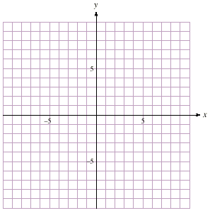

ex. Write the equation in vertex form of each parabola graphed below.
- b)

ex. A parabola has vertex (6 , -5) and passes through the point (2 , -9). Determine its equation in vertex form.

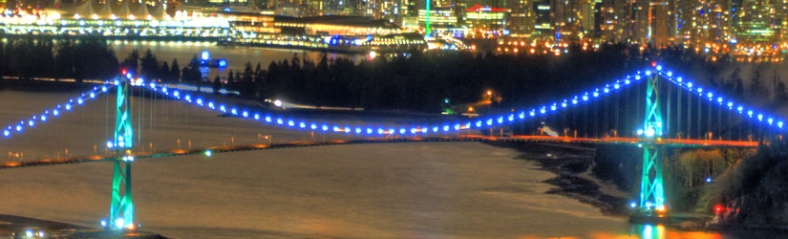
ex. The deck of the Lions’ Gate Bridge in Vancouver is suspended from two main cables attached to the tops of two supporting towers. Between the towers, the main cables take the shape of a parabola as they support the weight of the deck. The towers are 111 m tall relative to the water’s surface and are 472 m apart. The lowest point of the cables is approximately 67 m above the water’s surface.
- Model the shape of the cables with a quadratic function in vertex form.

- Determine the height above the surface of the water of a point on the cables that is 90 m horizontally from one of the towers. Express your answer to the nearest hundredth of a meter.

Practice: pg. 157/ # 4 (omit intercepts), 5 – 11, 14, 16 – 18, 21

