Unit 2: Quadratic Functions
2.1 Quadratic Functions in Vertex Form I

Quadratic Function:

Parabola:

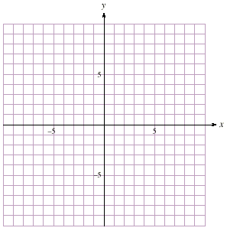
ex. Complete the table of values and graph $y=x^{2}$
$$x$$ | $y$
-3
-2
-1
0
1
2
3

Vertex:

Minimum/Maximum Value:

Axis of Symmetry:

Vertex Form of a Quadratic Function:

Translation:

Vertical Translations: $y=x^{2}+q$ or $f(x)=x^{2}+q$

ex. Sketch:
- $y=x^{2}+3$

- $f(x)=x^{2}-4$

Horizontal Translations: $y={\left(x-p\right)}^{2}$ or $f(x)={\left(x-p\right)}^{2}$

ex. Sketch:
- $f(x)={\left(x-5\right)}^{2}$

- $y={\left(x+2\right)}^{2}$

Combinations: $y={\left(x-p\right)}^{2}+q$ or $f(x)={\left(x-p\right)}^{2}+q$

ex. Complete without graphing, then sketch:

- $f(x)={(x-1)}^{2}-5$
- $y={(x+3)}^{2}+1$

Vertex:

Axis of Symmetry:

Domain:

Range:

Max/Min:

Vertex:

Axis of Symmetry:

Domain:

Range:

Max/Min:

Practice: pg. 157 / #2
& WS3.1A

