Unit 5: Non-Right Triangle Trigonometry
5.1 Right Angle Trigonometry Review

Ex. Write Trigonometric Ratios
Write each trigonometric ratio.

a) sin A

b) cos A

c) tan A

d) sin B

e) cos B

f) tan B

Ex. Evaluating ratios & finding angles
a) Evaluate each ratio, to four decimal places.

sin 42° cos 68° tan 25°

b) Determine each angle measure, to the nearest degree.

sin θ = 0.4771 cos β = 0.7225 $\tan{θ}=\frac{5}{4}$

Ex. Finding missing sides and angles
Determine the indicated missing side or angle.
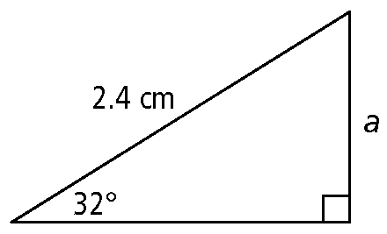
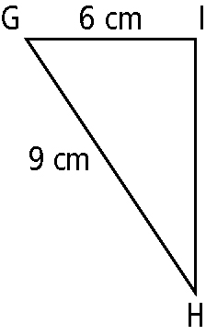
$x$
$x$

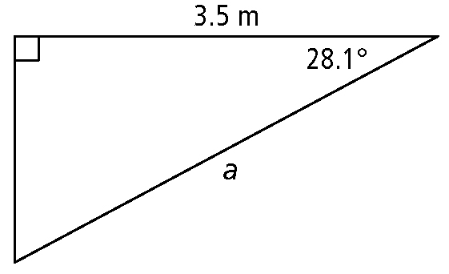
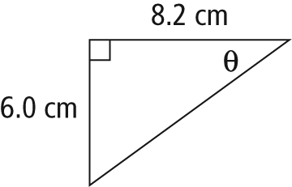

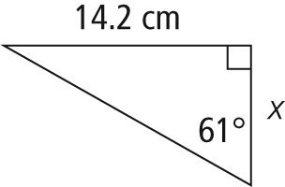
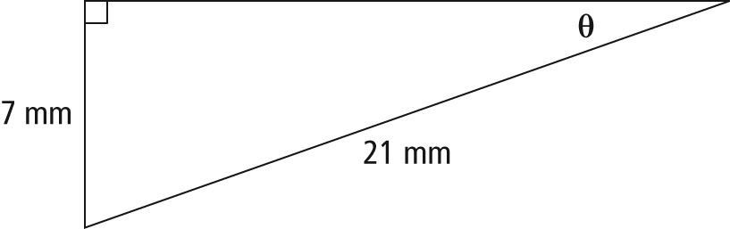

Ex. Solving a triangle
Determine the missing measurements in the right triangle. Express side lengths to the nearest tenth of a centimetre and angles to the nearest degree.
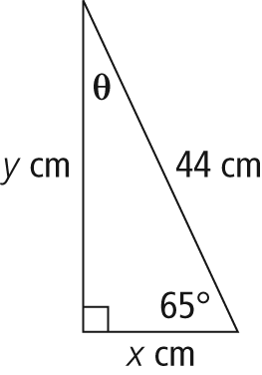

Ex. Solving Problems
A small boat is 95 m from the base of a lighthouse that has a height of 36 m above sea level. Calculate the angle of elevation from the boat to the top of the lighthouse. Express your answer to the nearest degree.

A person flies a kite such that the angle of depression from the kite to the person is 62°. Determine the height of a kite above the ground if the kite string extends 480 m from the ground. Express your answer to the nearest tenth of a metre.

Practice: Worksheet 5.1/ #3 – 6ab, 7, 8, 9 – 10ab, 11i&ii, 12 – 14ab, 15 – 20

