4.0 Rationals (Fractions) Review
Rational Numbers – any number that can be written in the form $\frac{a}{b}$ (where $a$ and $b$ are integers)
Ex. $\frac{a}{b}$

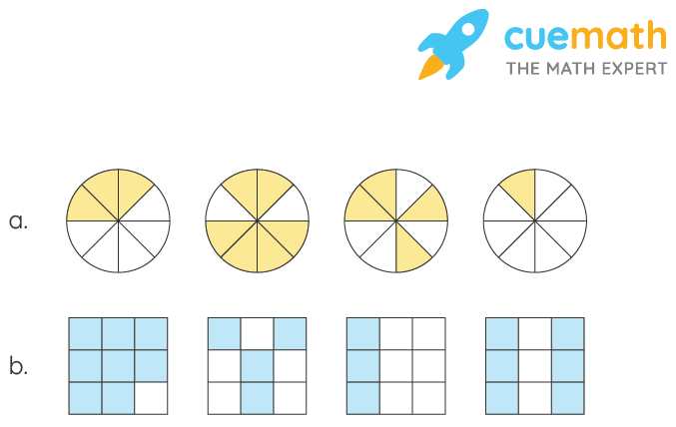
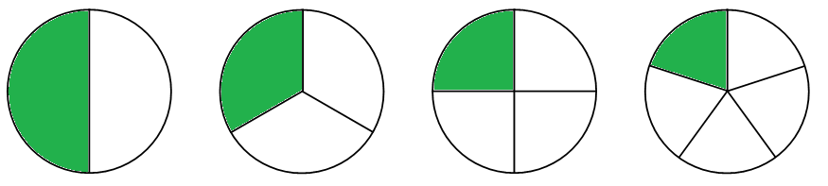
Ex. State each fraction shown:

Equivalent Fractions – rationals that represent the same value
Ex. Write three equivalent fractions to each given rational:
$\frac{1}{2}=$ $\frac{4}{10}=$ $\frac{3}{4}=$

Ex. Decide if each equivalency statement is true or false:
$\frac{3}{5}=\frac{9}{15}$ $\frac{9}{12}=\frac{7}{8}$ $\frac{6}{10}=\frac{12}{20}$

Lowest Terms (simplest form) – an equivalent fraction where the numerator and denominator have no common factor other than 1
Ex. Determine if each fraction is in lowest terms, if not reduce it to lowest terms:
$\frac{2}{5}$ $\frac{4}{12}$ $\frac{5}{20}$ $\frac{8}{15}$

