Unit 6: Solving Systems of Linear Equations
6.1 Solving by Graphing & Number of Solutions
Recall: To SOLVE an equation means to identify the value of the variable which satisfies the equation (makes the equation true).

Ex. Solve $2x-1=9$

System of Linear Equations:

Ex. Solve the system graphically: $y=2x$ and $y=x+2$

Algebraic Verification

Solution (to a system of linear equations):

Ex. Consider the system of linear equations $2x+y=2$ and $x-y=7$. Identify the solution of the system by graphing, then verify the solution.

 | Intersecting Lines | Parallel Lines | Coincident Lines
Number of Solutions
Graph | 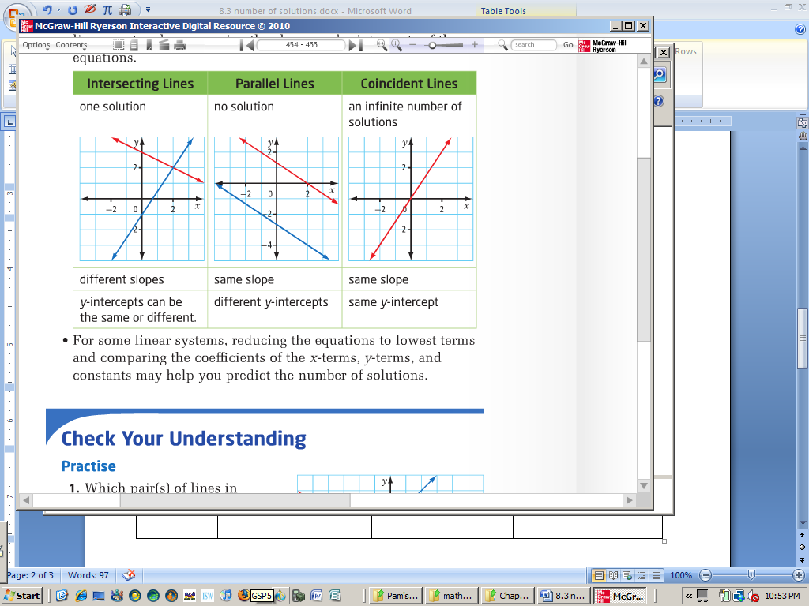
Slopes:
y-intercepts:
Before solving, you can predict the number of solutions by comparing the ____________________

and the ________________________ of the equations.

Ex. Predict the number of solutions for each system of linear equations. Explain your reasoning.

a) $y=2x-3$ b) $4x+10y=30$ c) $10x-6y=-12$
$y=\frac{1}{2}x+3$ $2x+5y=35$ $21y=42+35x$

Practice: Worksheet
pg. 427/ # 5abc, 19
pg. 454/ # 1 – 4, 6, 11, 12, 14

