5.4 Parallel & Perpendicular Lines

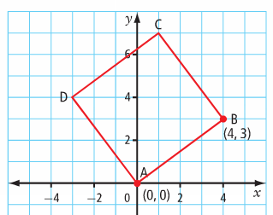
ABCD is a square. Calculate the slope of each line segment.

Compare the slopes of pairs of parallel line segments. What do you notice?

Compare the slopes of pairs of perpendicular line segments. What do you notice?

Parallel lines:

Perpendicular lines:

Ex. State whether the lines in each pair are parallel, perpendicular, or neither.

a) $y=3x-6$ b) $y=4x+3$ c) $y=2x+6$
$y=-\frac{1}{3}x+4$ $y=4x-5$ $6x+3y+3=0$

d) $y-4=0$ e) $y=\frac{2}{5}x-6$ f) $y=3x-4$
$x+1=0$ $5x+2y=8$ $y=3x+\frac{1}{4}$

Ex.Write the equation of a line that is parallel to $2x–y+4=0$ and through $(1,-6)$. Express the equation in slope – intercept form and in general form.

Ex. Write the equation of a line perpendicular to $3x+2y–6=0$ with an x-intercept of 9. Express the equation in slope – intercept form and in general form.

Ex. For the pair of slopes $-\frac{2}{n}$ and $\frac{5}{2}$ , what is the value of n if the lines are parallel? What is the value of n if the lines are perpendicular?

Practice: pg. 390/# 1acegh, 2bfgh, 3, 4, 5acf, 6aceg, 7bdef, 9 – 11, 13, 15, 16, 19, 20

