5.1B Slope-Intercept Form

y-intercept:

slope-intercept form:

Ex. Graph each line using the slope and y-intercept:
$y=\frac{2}{3}x-4$

$y=-3x+5$

Ex. State the equation of each line shown in slope-intercept form:
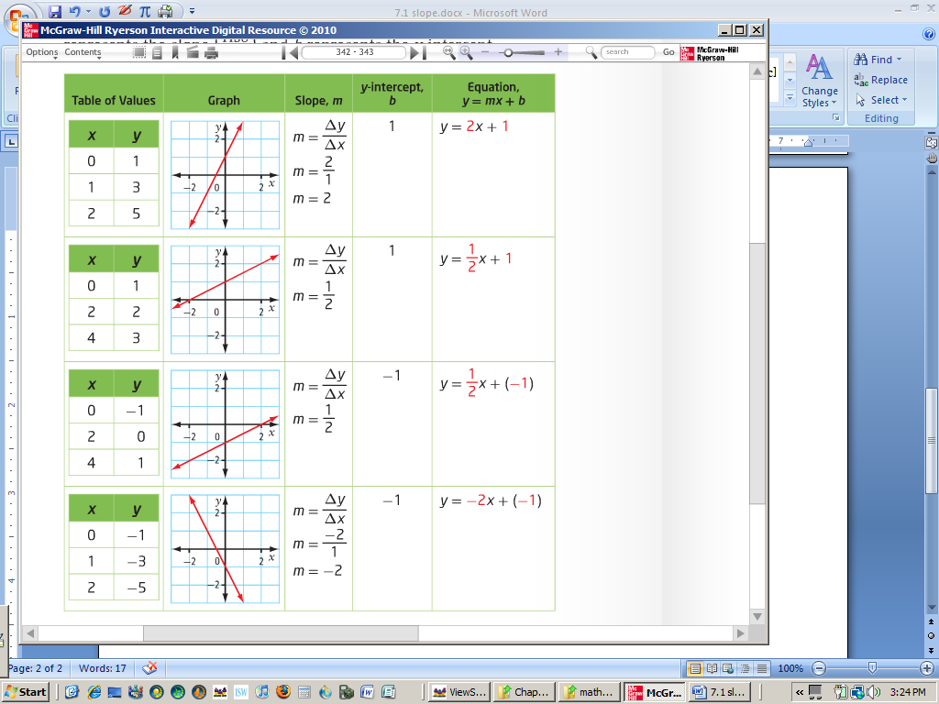

Ex. The line $y=\frac{1}{3}x+b$ passes through the point $(6, -1)$. Determine the value of $b$.
Ex. The line $y=mx+5$ passes through the point $(-2, 1)$. Determine the value of $m$.

Ex . A students’ council rents a portable dunk tank as a fundraising activity. Students pay for the chance to hit a target with a ball and dunk someone into a tank of water. The relationship between the number of balls thrown, x, and the profit, y, in dollars, may be represented by the equation $3x–2y–600=0$.
- Rewrite the equation in slope – intercept form.

- State the slope of the line. What does the slope represent?

- Identify the y-intercept. What does it represent?

- The break-even point is the point at which the money raised equals the money spent. How many balls must the students sell to reach the break-even point?

Ex. An archaeologist simulates a First Nations method of boiling water. If the starting temperature of the water is 10 ºC and the equation W = mt + 10 models how the temperature, W, increases over time, t (min).
- After 5 min, the water temperature is 19 ºC. Determine the value of the parameter m. What does m represent?

- How long will it take for the water to boil?

