Unit 5: Linear Equations & Graphs
5.0 Slope
Slope:

or or

A positive change in both the vertical and horizontal values leads to a

__________________ slope.

A negative change in both the vertical and horizontal values leads to a

_________________ slope.

A negative change in one and a positive change in the other leads to a

_________________ slope.

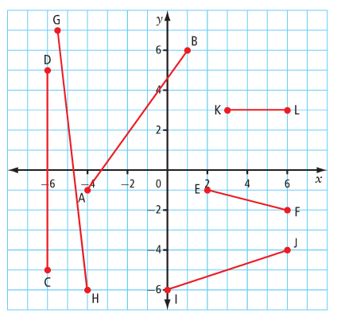
Ex. Classify the slope of each line segment as positive, negative or neither. Then, calculate each slope.

Slope formula:

Ex. What is the slope, m, of each line segment with the given endpoints?

a) S(-3, 6) and T(5, 2) b) H(4, 3) and K(4, 8) c) M(-9, -7) and N(-1, -7)

Ex. The point (-3,2) is on a line that has a slope of $\frac{-3}{4}$. List three other points on the line.

Ex. The point (-6,1) is on a line that has a slope of $\frac{1}{3}$. List three other points on the line.

Ex. Graph the line with given point and slope:

- $\left(-3, 2\right), m=-\frac{1}{3}$

- $\left(0, -4\right), m=2$

- $\left(5,0\right),m=undefined$

Practice: WS (152/153) – on sheet
pg. 325/ # 1, 4 – 6, 12, 16

