4.5 Functions

Function:

Function Notation:

Ex. For each pair of relations, decide which relation is a function and which is not a function. Explain your choice.

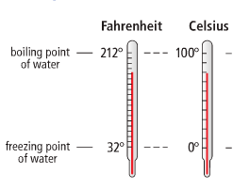

Ex. The function $F(C) = 1.8C + 32$ is used to convert a temperature in degrees Celsius $(°C)$ to a temperature in degrees Fahrenheit $(°F)$.

a) Determine F(25). Explain your answer.

b) Determine C so that F(C) = 100. Explain your answer.

Ex. Skye has a cell phone plan for a monthly fee of $20 plus 25¢ for each text message to or from a number not on a list of favourites.
- Write the relation modeling the monthly bill in function notation using C as the name of the function & n as the number of additional text messages.

- Make a table of values. Graph the function if Skye sends up to four additional text messages.

- If Skye’s cell phone bill for a certain month is $22.25, how many additional text message charges are there?

Practice: pg. 311/ # 1, 2, 4 – 8, 11, 12a, 14, 15, 17
& Worksheet(#175) – on sheet

