4.4 Domain & Range

Domain:

Range:

Ex. State the domain and range of the following relation:
$$\left(3, -2\right)\left(-1, 3\right)\left(4, 7\right)\left(-2, 0\right)(0, 3)$$

Ex. For each graph, give the domain and range. Use words, a number line, interval notation, and set notation.
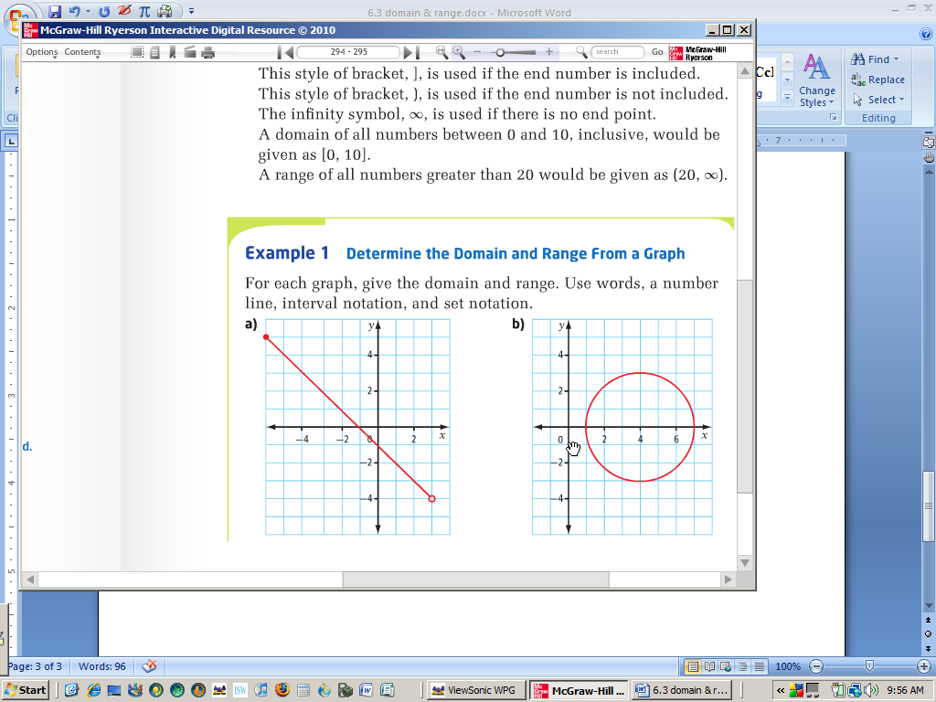
a)

b)

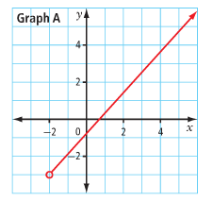
c)

d)

Ex. The Great Wheel was one proposed to be built in Beijing in the People’s Republic of China. If finished, it would have been the largest Ferris wheel in the world. The wheel was supposed to have a diameter of 193 m and would have reached a maximum height of 208 m. The graph shows a rider’s height relative to the ground for a 20 minute ride through one rotation.
a) What are the values of the points A, B, C, and D and what do they represent?
b) What are the domain and the range of the graph?

Practice: pg. 301/ # 2, 3, 4a, 6ab, 8, 10

