Unit 4: Linear Relations & Functions
4.1 Graphs of Relations

* Working in pairs complete the investigate activity on pg. 268 – 269 of your textbook. Record your answers on separate sheet (one sheet per pair).

A graph is an effective way to show the relationship between two quantities. A constant rate of change is represented graphically by a _________ line. The steepness of the line indicates the rate at which one quantity is changing in relation to the other.

A steeper line indicates a __________ rate of vertical change on the red line than on the blue line. This change may indicate an increase or a decrease.
A horizontal line means that there is _____ rate of change.
Every value on the horizontal axis is related to the same value on the vertical axis.

Not all relationships are represented by a straight line. A curve shows that the rate of change is not constant.

As quantity B increases, the increase in quantity A is gradual at first. It then becomes much greater.

As quantity B increases, the increase in quantity A slows until quantity A reaches a maximum value. Then, quantity A decreases.

Ex. Wakeboarding has grown to be a popular water sport. The graph shows the distance that a wakeboarder is from her starting point on Last Mountain Lake in Saskatchewan. Describe what the boarder is doing.

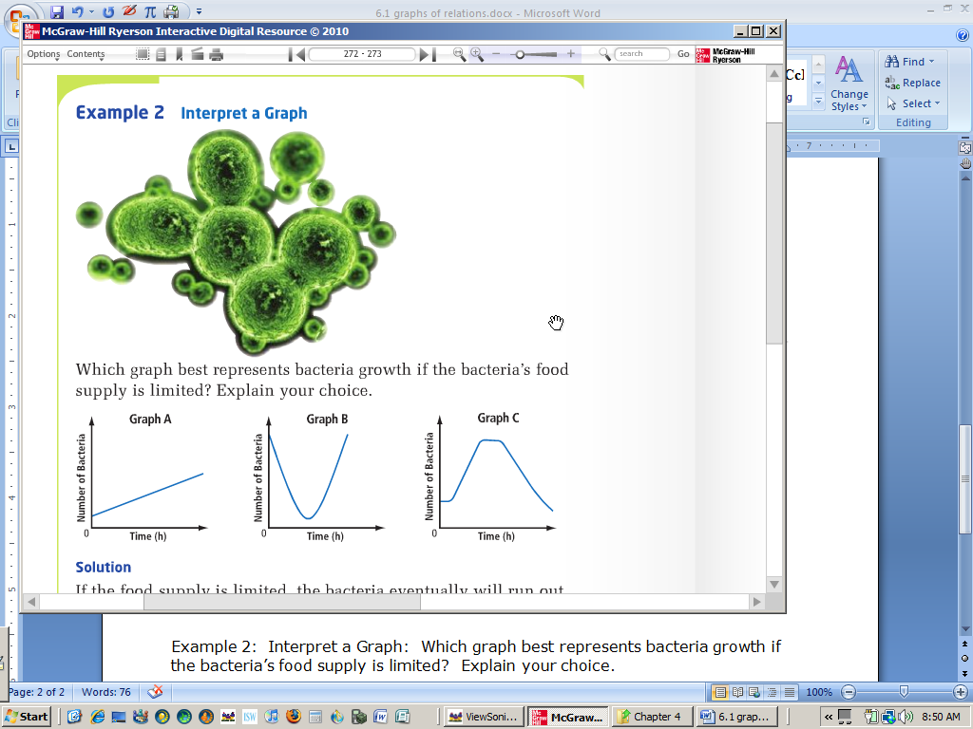
Ex. Which graph best represents bacteria growth if the bacteria’s food supply is limited? Explain your choice.

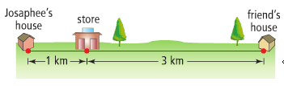
Ex. Josephine leaves her home and walks to the store. After buying a drink, she slowly jogs to her friend’s house. Josephine visits with her friend for a while and then runs directly home. Using the distances shown, draw a distance-time graph that shows Josephine’s distance from her house. Explain each section of your graph.

Practice: pg. 274/ # 1 – 4, 6, 7, 10 - 15

